**The Distributive Property Practice**

**Name _______________________________ Date ________________**

**Simplify**

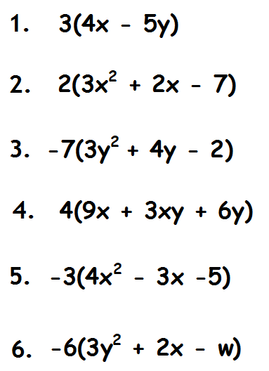

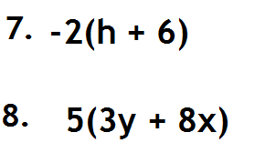

Teacher Twins©2014