Coordinate Graphing Quadrants and Reading Ordered Pairs Practice
Name _______________________________ Date _________________
Name the ordered pair for each point and identify the quadrant the point is in.

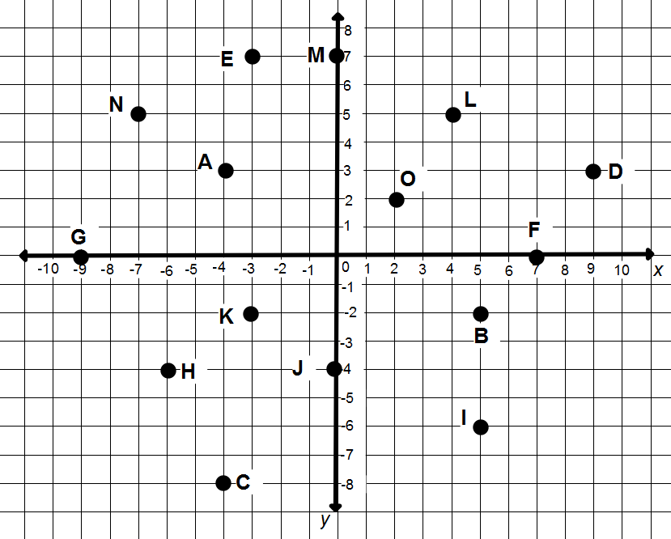

A _________________ B _________________ C _________________

D _________________ E _________________ F_________________

G _________________ H _________________ I_________________

J _________________ K_________________ L _________________

M _________________ N _________________ O_________________

