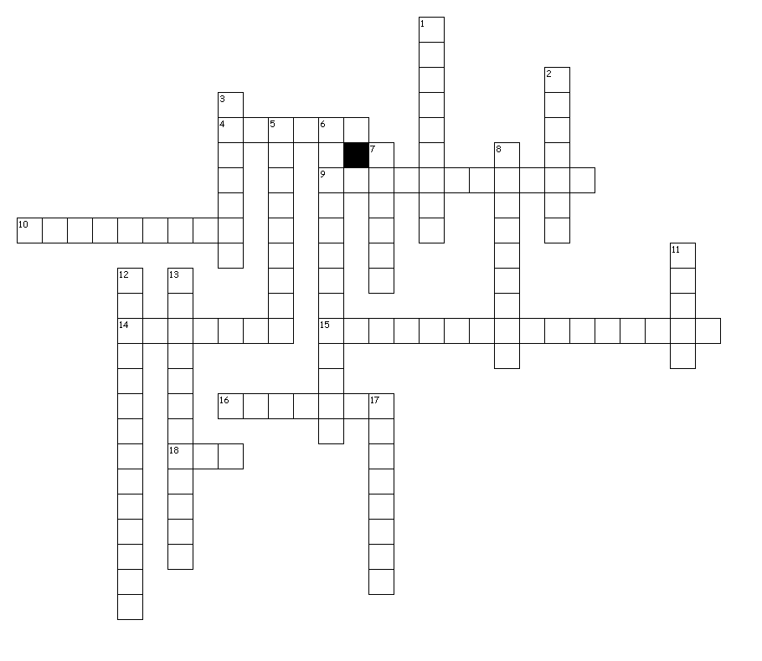

**Word Bank**

Economics

Consumers

Capital goods

Resources

Natural resources

Market

Command

Traditional

Mixed

Specialization

GDP

Entrepreneurs

Imports

Exports

Tariff

Embargo

Bartering

Scarcity

**Economics Vocabulary Words**

**Crossword Puzzle**

**Name:_____________________**

**Date:______________________**

**Period:____________________**

**Across**

4. Businesses supply products with little government interference based upon consumer demand.

9. social roles and culture determine how goods and services are produced.

10. trading without using money

14. Items that are taken out of the country to sell

15. Resources provided by nature and used to produce goods and services.

16. Items that are brought into a country to sell

18. The total value of the goods and services that a country produces each year.

**Down**

1. The study of how people, businesses and countries use limited resources, such as money and materials.

2. The government determines what goods are produced.

3. a ban placed on goods

5. Items used to create the product or service.

6. People who start and own private businesses.

7. taxes on imported products

8. People who use the goods and services

11. elements of market and command economies

12. focusing on one product or service; usually one becomes skilled

13. factories, machinery, and technology

17. the limited supply of something