Solving Multi Step Equations Practice 2
Name _______________________________________ Date _________________
Solve each equation. Show your work.
- 5 = 5x – 23 + 2x

- 11x – 8 – 6x = 22

- 4(x + 6) = -7

- -2(3x – 8) = 30

- 8x + 10 – 6x = 70

- -2x – 8x = -20

- – (-4x + 7) = 9

- 14 = -2(x – 4)

Teacher Twins©2014

Solving Multi Step Equations Practice 2
Name _______________________________________ Date _________________
Solve each equation. Show your work.
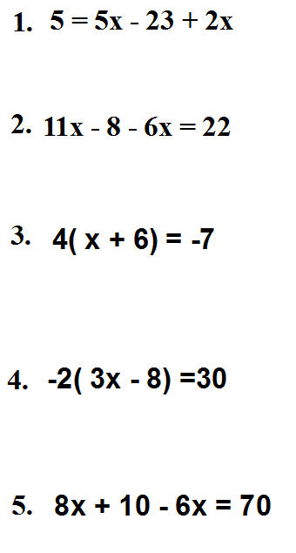
x = -2$\frac{1}{3}$
x = -7$\frac{3}{4}$
x = 30
x = 6
x = 4
Teacher Twins©2014

- -2x – 8x = -20

2
- – (-4x + 7) = 9

4
- 14 = -2(x – 4)
-3

