Reflections on the Coordinate Plane
Graph triangle ABC on the coordinate plane. A (3, 7), B (3, 2), C (7, 2)
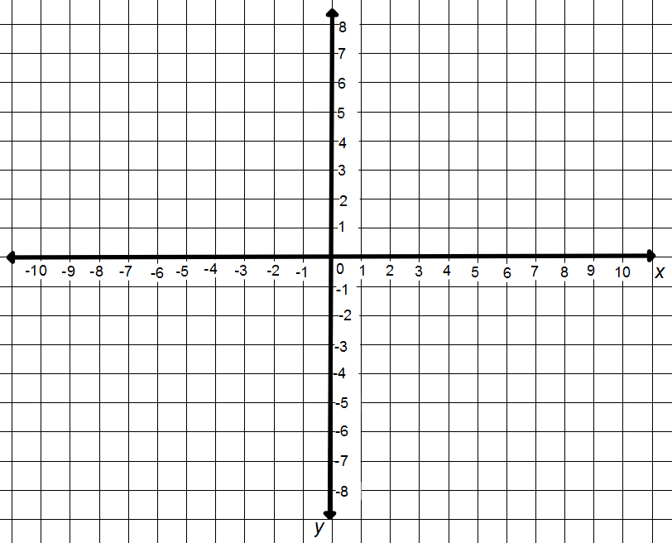

Graph triangle HIJ on the same coordinate plane. H (-3, 7), I (-3, 2), J (-7, 2)

What is the relationship between triangle ABC and triangle HIJ?

You should have noticed that all points on triangle ABC and triangle HIJ are ____________ units away from the y axis.

Graph triangle XYZ on the same coordinate plane. X (3, -7), Y (3, -2), Z (7, -2)

What is the relationship between triangle ABC and triangle XYZ?
You should have noticed that all points on triangle ABC and triangle XYZ are ____________ units away from the x axis.

A ______________ is a figure flipped across a line. The new figure that is created is a __________ ____________of the original figure.
The line that the figure is flipped across is called the line of reflection.

Across which line do you reflect triangle ABC to get triangle HIJ?
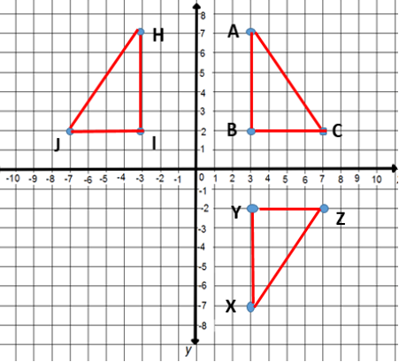

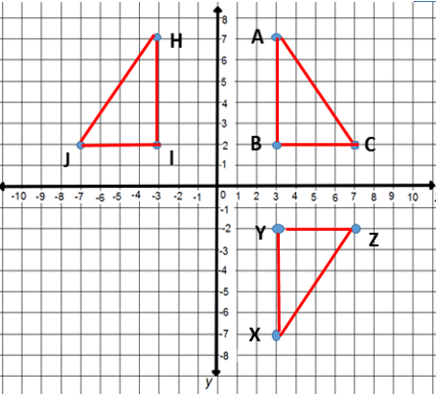
Across which line do you reflect triangle ABC to get triangle XYZ?

Example 1
What is the reflection of (-3, 6) across the y axis?
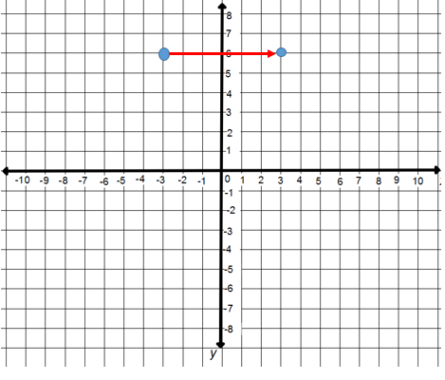

Example 2
What is the reflection of (-3, 6) across the x axis?

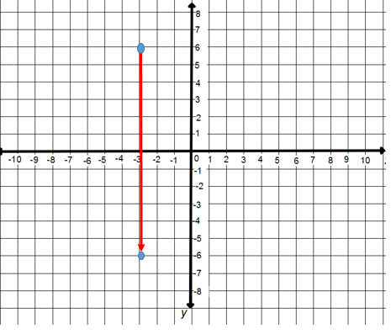

Practice
You are given the points (3, 8), (0, 7), (-4, 2) and (-5, -1). What is the reflection of each point across the x-axis? Across the y-axis?

