Solving Equations with Variables on Both Sides Practice 1
Name ________________________________________ Date ______________
Solve each equation. Show your work.
- 6x + 9 = 4x – 15
Teacher Twins©2014

- 7x + 2 – 5x = 3x – 23

- 5c – 2 = 32 + 4c

- $\frac{1}{3}$(18 + 12x) = 6(2x – 7)

- 4(x + 20) = 20x + 40

- 8x – 2 = -9 + 7x

- b + 5 = -5b + 5

- x – 1 = 3x – 8 + 5x

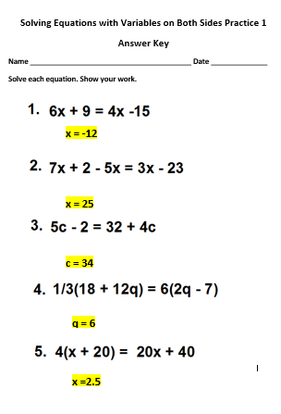
- 8x – 2 = -9 + 7x
-7

- b + 5 = -5b + 5

0
- x – 1 = 3x – 8 + 5x
1

