Finding the Distance Between Two Points Guided Notes

Example 1 What is the distance between (-5, 6) and (-2, 6)? (Use graph below)

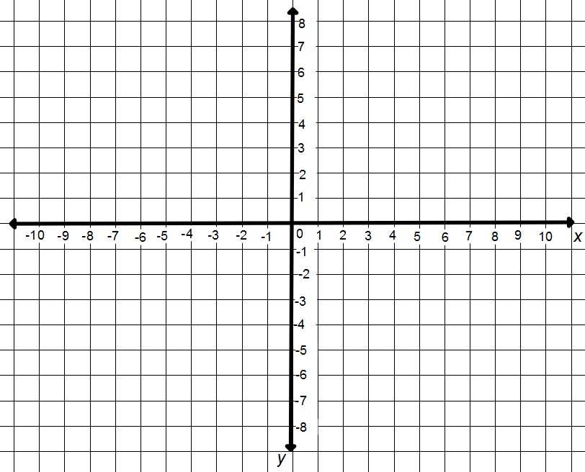

Example 2
What is the distance between (7, 1) and (7, 6)? (Use graph above)

Example 3
What is the distance between (-2, 1) and (-2, -6)? (Use graph above)

You can use _____________ _____________ to help you find the distance between the points.

Find the distance between (-2, 1), (-2, -6)

You can find the distance of both points from the y-axis and add them.

1 is 1 unit above the y-axis -- 1

-6 is 6 units below the y-axis -- -6

1 + -6 = 1 + 6 = _______

Practice
Find the distance between each pair of points.
- (-5, 8), (-5, 2)
- (0, 4), (5, 4)
- (6, 7), (6, -4)
- (-5, 5), (7, 5)
TeacherTwins©2015

