Solving Equations with Variables on Both Sides Practice 2
Name_____________________________________ Date__________________
Solve each equation. Show your work.
- -2x + 15 = -4x – 3

Teacher Twins©2014

- 3y + 7 = 2y + 8

- 3(x + 5) = 3x + 12

- 3x – 5 = 7x + 7

- 4x + 7 – 2x = 3 + 2x + 4

- b – 4 = -9 + b

- 2(4y – 3) – 8 = 2y + 4

- 4x – 16 = 4(x - 4)

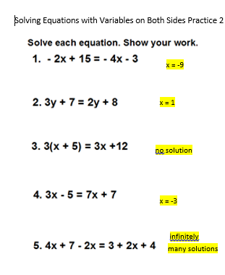
- b – 4 = -9 + b
no solution

7. 2(4y – 3) – 8 = 2y + 4
3

- 4x – 16 = 4(x - 4)
Infinitely many solutions

