Finding Distances on the Coordinate Plane Day 2 Guided Notes

On a coordinate plane map, the gym is located at (-2, 5). The middle school is located at (7, 5). If each unit represents one block, how far will Jim have to walk from the school to the gym? Use the graph below.
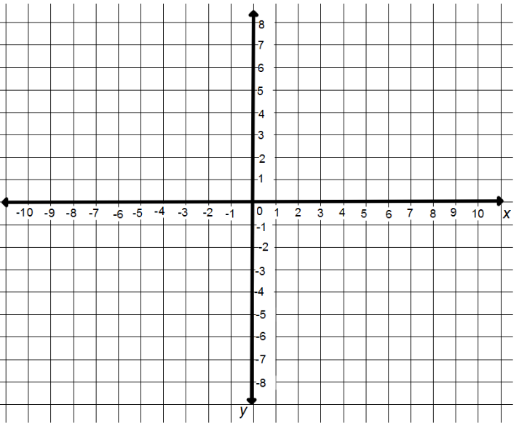

On a coordinate plane map, the park is located at (-1, 3). Joshua’s house is located at (-1, -8). If each unit represents one block, how far will Joshua have to walk to go to the park?

TeacherTwins©2015

On a coordinate plane map, Kim’s house is located at (-6, 5). Karen’s house is located at (-6, -4). The shopping mall is located at (7, -4).
How far will Kim travel if she leaves her house, picks up Karen and then goes to the mall?

TeacherTwins©2015

