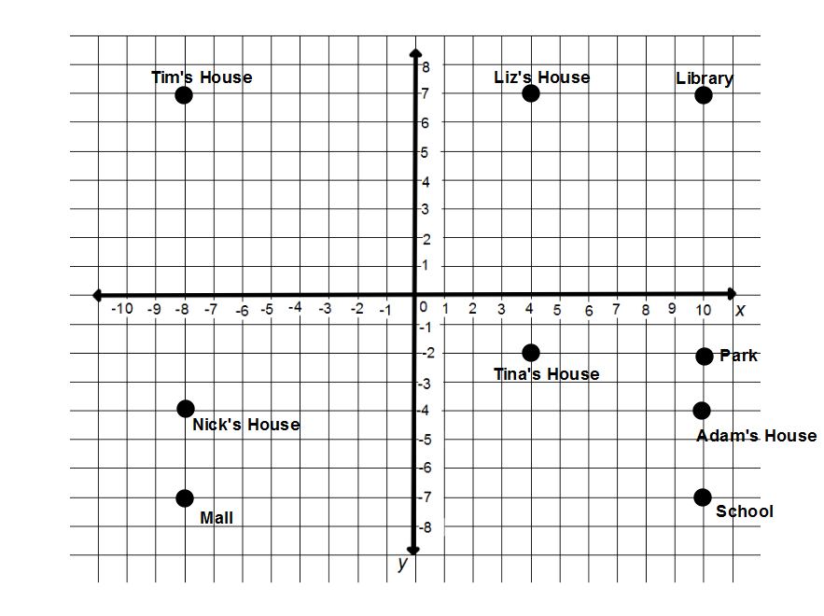
Finding Distance on the Coordinate Plane Day 2 Practice
Name ___________________________ Date ___________ Class _________
Use the map to answer the questions.
- How far is it from Tim’s house to Nick’s House? ____________
- How far is it from the mall to the school? _____________
- If Nick goes by and gets Adam, how far will he travel to get to school? _________
- If Jen lives at (4, -7), how far is it from her house to the mall? ________
- If Caleb lives at (-7, -2), how far is it to the park and back? ___________
- Paul lives at (9, 0) on the map. John lives at (9, -1). The baseball park is at (-6, -1). If Paul goes by and picks up John on the way to the baseball park how far will he travel? ___________________
- Meg lives at (-5, 0). The grocery store is at (9, 6). If she goes by and picks up Paul on the way to the grocery store, how far will she travel? ______
- How far will it take Tina to walk to school if she must go past Liz’s house and the library? ___________

