Solving Systems of Equations by Graphing Practice
Name _________________________________________________________ Date _______________
Solve by graphing.
- y = $\frac{1}{2}$x 2. y = -3x + 6
y = -2x + 10 y = 2x - 4

- y = -6 4. y = 2x + 1
y = -4x + 2 y = 2x - 4

5. y = -2x -1 6. y = 3x + 6
y = 2x + 3 y = x + 2

7. y = 5x – 3 8. y = $\frac{-1}{2}$ x – 1
y = -3x + 13 y = $\frac{1}{4}$x - 4

Teacher Twins©2014

Teacher Twins©2014
Solving Systems of Equations by Graphing Practice Answers
Name _______________________________ Date _______________
Solve by graphing.
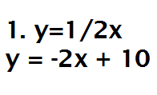(4, 2) 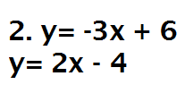 (2, 0)

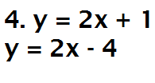
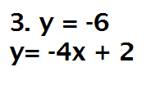 (2, -6) no solution

5. y = -2x -1 6. y = 3x + 6
y = 2x + 3 y = x + 2

(-1,1) (-2,0)
7. y = 5x – 3 8. y = $\frac{-1}{2}$ x – 1
y = -3x + 13 y = $\frac{1}{4}$x - 4
(2,7) (4,-3)

Teacher Twins©2014

