Solving Two Step Equations Practice 1
Name ______________________________________________________ Date ___________________
Solve each equation. Show your work.

- 2x – 17 = 121

- -$\frac{1}{3}$ x + 12 = - 48

- $\frac{x}{-2}$ + 24 = 13

- -5 + 2y = 24

- -3x + 35 = -17

- 7t – 15 = 12

- 9x – 7 = -7

- $\frac{x}{5}$ + 6 = 15

- $\frac{x+9}{3}$ = 8

Teacher Twins©2014
Solving Two Step Equations Practice 1
Answer Key

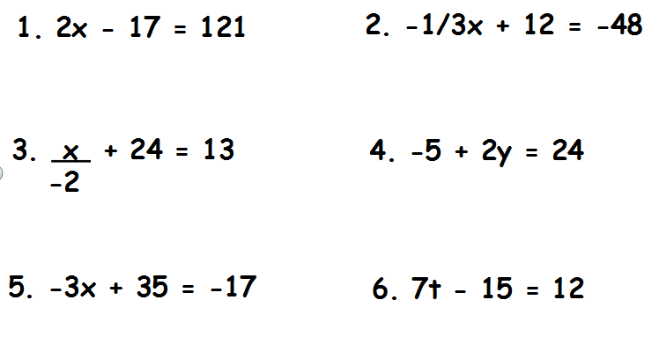
x = 3$\frac{6}{7}$
x = 17$\frac{1}{3}$
x = 69
x = 14.5
x = 22
x = 180

- 9x – 7 = -7
0
- $\frac{x}{5}$ + 6 = 15
45

- $\frac{x+9}{3}$ = 8

Teacher Twins©2014
1

Teacher Twins©2014

