Solving Two Step Equations Practice 2
Name _________________________________ Date ________________
Solve each equation. Show your work.

- -2x + 6 = - 22

- $\frac{7}{2}$ y + 6 = 76

- $\frac{- 4+8x}{2}$ = 78

- $5-3y=132$

- 4 = $\frac{1}{2}$ m + 3

- 19 = -2x + 4

- 4x + 8 = 24

- $\frac{x}{5}$ + 9 = 12
Teacher Twins©2014
Solving Two Step Equations Practice 2
Answer Key
Name _________________________________ Date ________________
Solve each equation. Show your work.
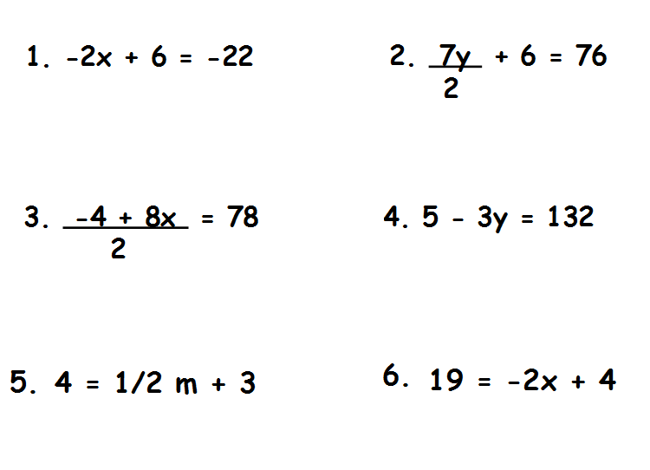
x = -42 $\frac{1}{3}$
x = -7.5
x = 2
x = 20
x = 20
x = 14

- 4x + 8 = 24
4

- $\frac{x}{5}$ + 9 = 12 15

Teacher Twins©2014

