Angle Relationships Practice
Name_________________________________________ Date________
Identify the pair of angles as adjacent, complementary, supplementary, or vertical.
1. _________ 2. __________
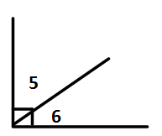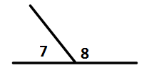
4. ___________
3._________

5. ____________

Find x.
6._________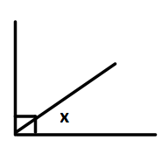 7. _______________
105⁰
45⁰
8. ________
77⁰

Teacher Twins©2014

Angle Relationships Practice Answer Key
Name_________________________________________ Date________
Identify the pair of angles as adjacent, complementary, supplementary, or vertical.
1. vertical 2. adjacent
3. complementary and adjacent

4. supplementary and adjacent

5. supplementary and adjacent

Find x.
6. 45⁰ 7. 105⁰
105⁰
45⁰
8. 103⁰

77⁰
Teacher Twins©2014

