Using Slope Intercept Form to Graph Practice
Name__________________________________________ Date _______________

Graph each line.
1. y = 3x -2 2. y = $\frac{-1}{2}$ x + 1

3. y = x + 3 4. y = -4x + 6

5. y = 2x 6. y = -x + 5

7. y = x 8. y = 6x – 3

9. y = $\frac{-1}{3}$x + 2 10. y = -3x + 1

Teacher Twins©2014

Using Slope Intercept Form to Graph Practice Answer Key
Name__________________________________________ Date _______________

Graph each line.
1. y = 3x -2 2. y = $\frac{-1}{2}$ x + 1
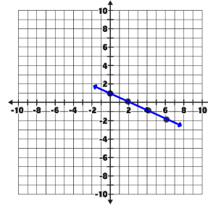
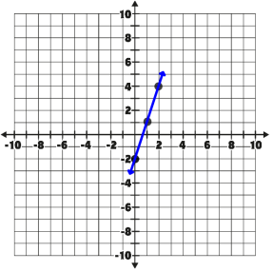

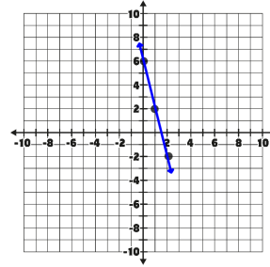
3. y = x + 3 4. y = -4x + 6
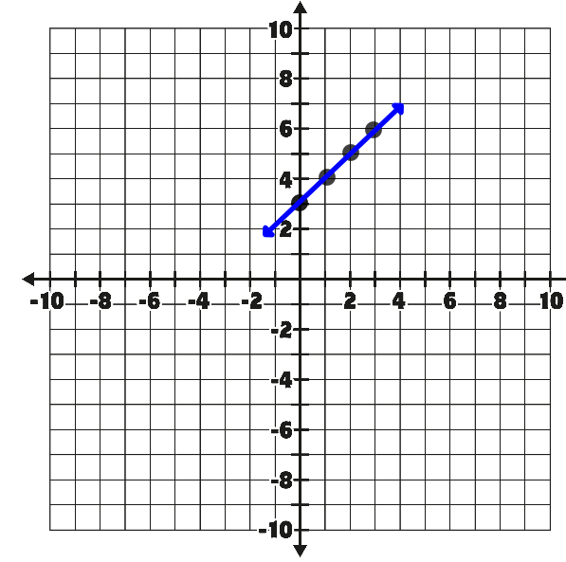
5. y = 2x 6. y = -x + 5
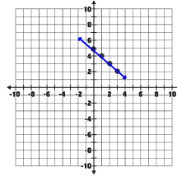
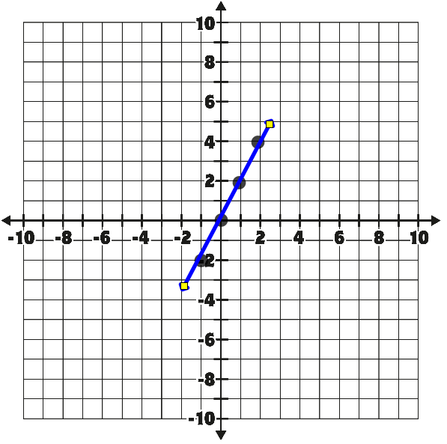
7. y = x 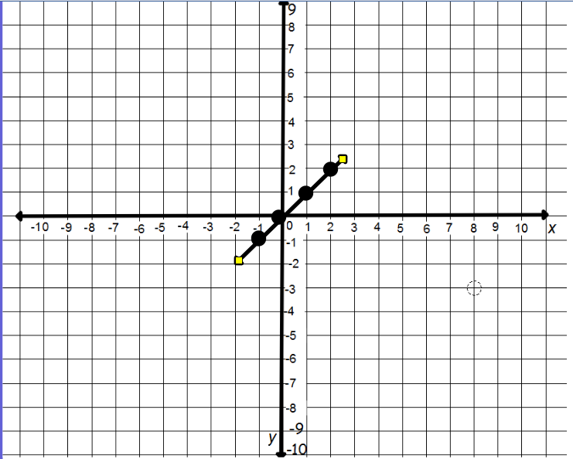 8. 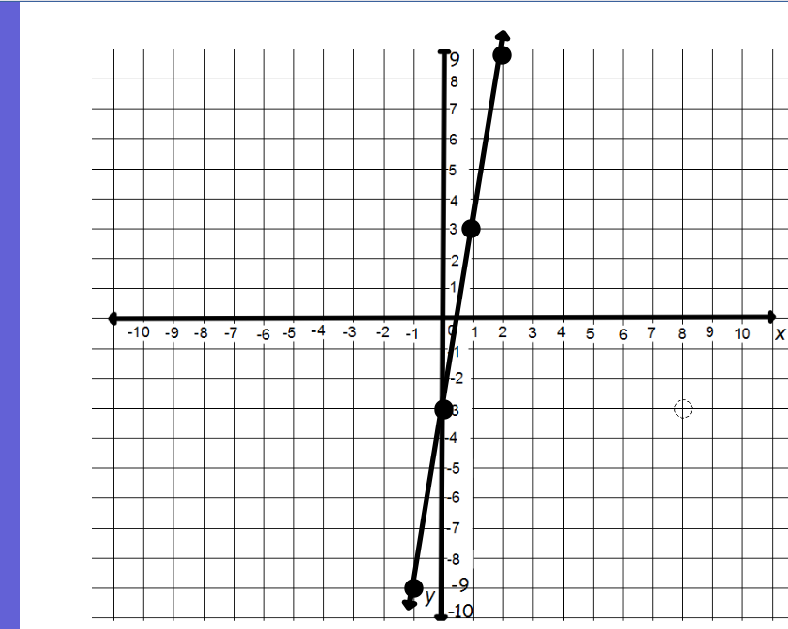
Teacher Twins©2014
9. y = -1/3x + 2 10. Y = -3x + 1
