Using Slope Intercept Form to Graph Practice Day 2
Name__________________________________________ Date _______________

Graph each line.
1. y = 2x -1 2. y = $\frac{-2}{3}$ x + 4

3. y = x - 4 4. y = -3x + 5

5. y = -x 6. y = -2x + 6

7. y = 2 8. y = x + 1

9. x = 3 10. y = -5

Teacher Twins©2014
Using Slope Intercept Form to Graph Practice Day 2 Answer Key
Name__________________________________________ Date _______________

Graph each line.
1. y = 2x -1 2. y = $\frac{-2}{3}$ x + 4
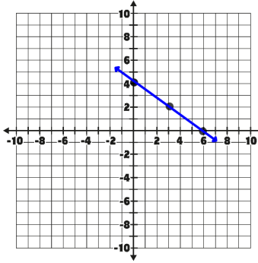
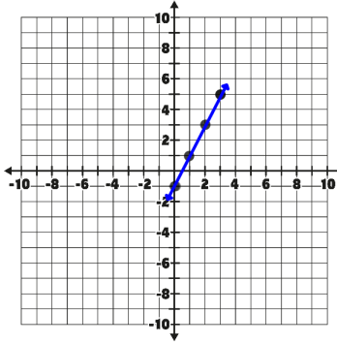

3. y = x - 4 4. y = -3x + 5
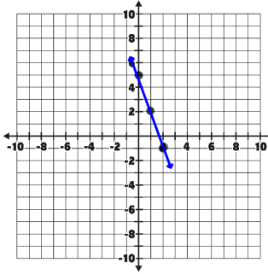
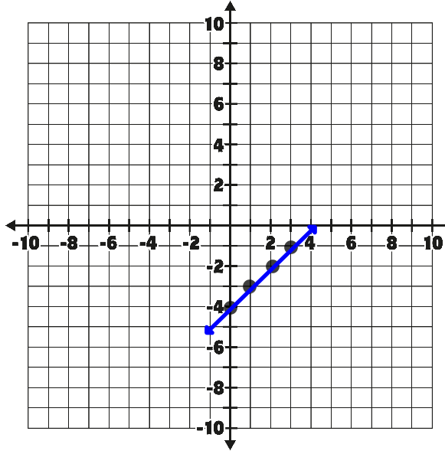
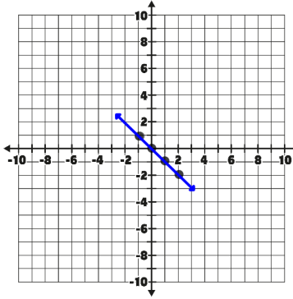
5. y = -x 6. y = -2x + 6
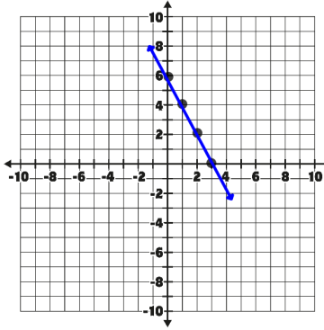

Teacher Twins©2014
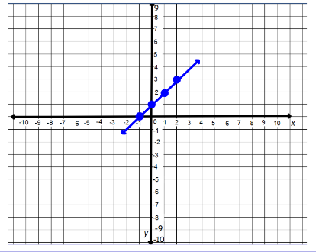
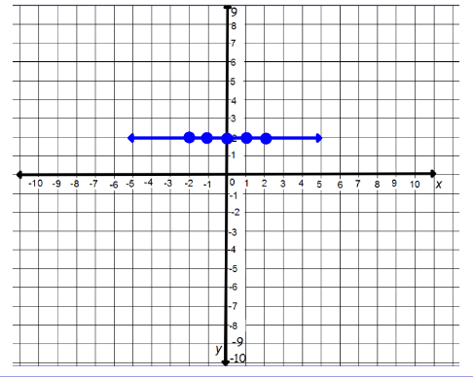
7. 8.

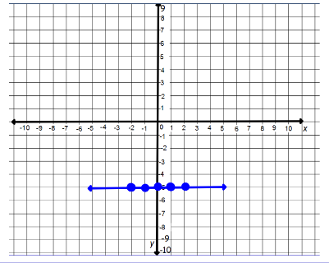
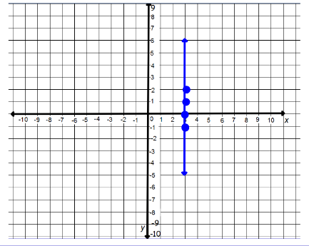
9. 10.

