Parallel Lines Cut by a Transversal Practice 2

Name ________________________________________ Date _________________

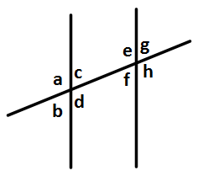

1. Write all of the pairs of alternate interior angles.

2. Write all of the pairs of alternate exterior angles.

3. Write all of the pairs of corresponding angles.

4. If < a = 165⁰, what is the measure of < e?

5. If < b = 66⁰, what is the measure of < h?

6. If < f = 54⁰, what is the measure of < e?

7. If < d = 103⁰, what is the measure of < a?

8. If < g = 77⁰, what is the measure of < b?

Teacher Twins©2014

Parallel Lines Cut by a Transversal Practice 2 Answer Key

Name ________________________________________ Date _________________



1. Write all of the pairs of alternate interior angles.

<c & < f and <d & <e

2. Write all of the pairs of alternate exterior angles.

<b & < g and <a & <h

3. Write all of the pairs of corresponding angles.

<a & <e, <b & <f, <c & <g, and <d & <h

4. If < a = 165⁰, what is the measure of < e?

165⁰

5. If < b = 66⁰, what is the measure of < h?

114⁰

6. If < f = 54⁰, what is the measure of < e?

126⁰

7. If < d = 103⁰, what is the measure of < a?

103⁰

8. If < g = 77⁰, what is the measure of < b?

77⁰

Teacher Twins©2014