Name ____________________________________________Date _________________

Ratios and Proportions/Review Lesson/6RP3 Lesson 12 –Jeopardy Worksheet

To win Jeopardy, every player on your team must show work in the spaces below!

Money, Money, Money, Monneeyy | World Record Holders | This or That | Math Trivia

Name ____________________________________________Date _________________

Ratios and Proportions/Review Lesson/6RP3 Lesson 12 – Class work

For #1 and 2, write each ratio in 3 ways. Make sure each ratio is in simplest forms.

1)
triangles to squares

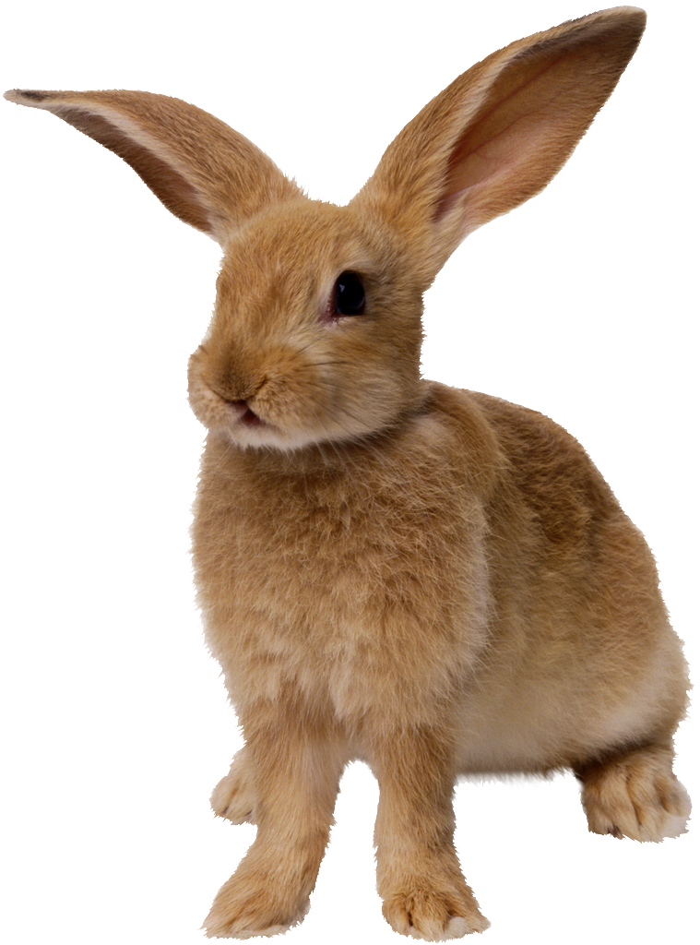
2) ears to feet

3) Mikayla has 4 quarters, 12 dimes, 10 pennies and 9 pennies in her change purse.
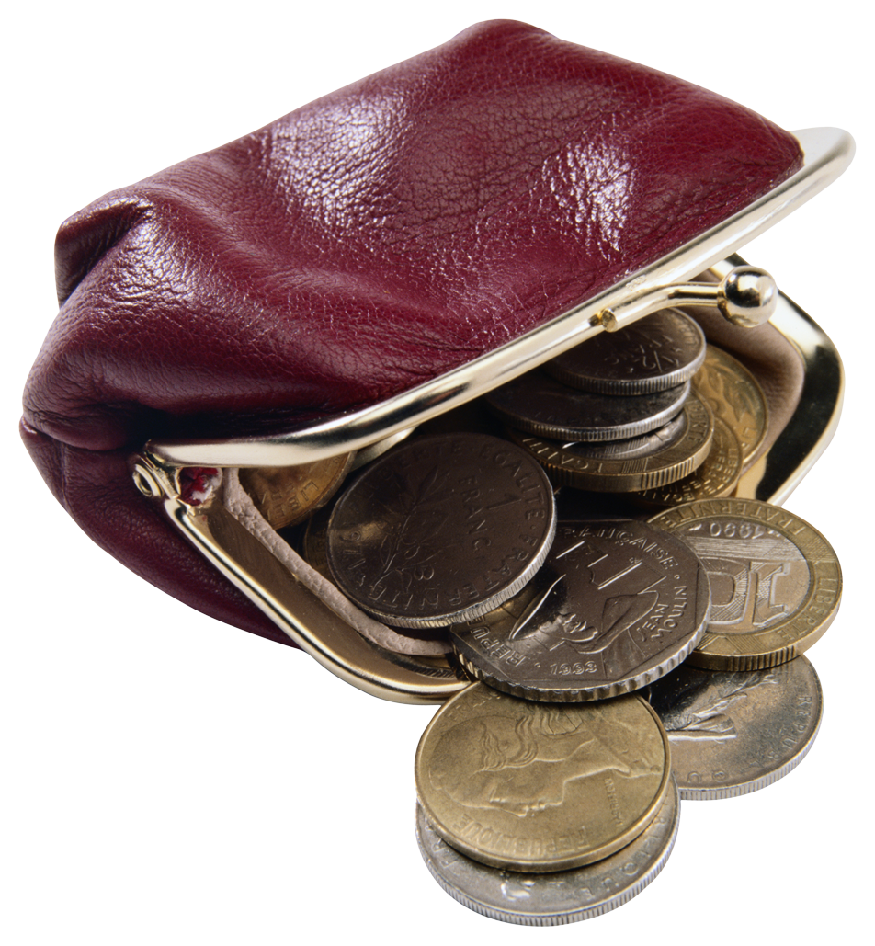
- Write a ratio in simplest form of dimes to pennies.

- Write a ratio in simplest form of quarters to dimes.

- Write a ratio in simplest form of pennies to total change in Mikayla’s purse.

4) Ricardo mixes together in 1 bag Gummi Bears and M&Ms. The ratio of Gummi Bears to M&Ms is 3 to 1. If there are 12 pieces of candy in one handful, how many M&Ms will there be?

Answer:_____________________

Gummi Bears | 1
M&Ms | 3
Total |  | 12

Solve #5 below, using a tape diagram. Then solve it using a ratio table.

5) A bag of trail mix has 2 grams of nuts for every 4 grams of dried fruit. In 200 grams of trail mix, how many grams are nuts?

Tape Diagram:  Answer: | Ratio Table:  Answer:

Name ANSWER KEY Date _________________

Ratios and Proportions/Review Lesson/6RP3 Lesson 12 – Class work Answers

For #1 and 2, write each ratio in 3 ways. Make sure each ratio is in simplest forms.

1)
triangles to squares
3 triangles : 7 squares

2) ears to feet
1 ear : 2 feet

3) Mikayla has 4 quarters, 12 dimes, 10 pennies and 9 pennies in her change purse.
- Write a ratio in simplest form of dimes to pennies.
10 dimes : 9 pennies

- Write a ratio in simplest form of quarters to dimes.
2 quarters : 5 dimes

- Write a ratio in simplest form of pennies to total change in Mikayla’s purse.
10 pennies: 35 total coins --> 2 pennies: 7 total coins

4) Ricardo mixes together in 1 bag gummi bears and M&Ms. The ratio of gummi bears to M&Ms is 3 to 1. If there are 12 pieces of candy in one handful, how many M&Ms will there be?
Answer: 9 M&Ms

Gummi Bears | 1 | 3
M&Ms | 3 | 9
Total | 4 | 12

Solve #5 below, using a tape diagram. Then solve it using a ratio table.

5) A bag of trail mix has 2 grams of nuts for every 4 grams of dried fruit. In 300 grams of trail mix, how many grams are nuts?
100 grams of nuts

