Amazon Rain Forest Virtual Field Trip
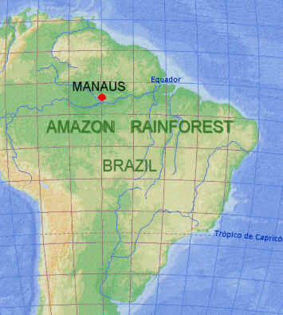

You are about to embark on a virtual field trip into the Amazon Rain Forest. You and your computer will be companions on this wild trek into lands like you’ve never seen before. As you go through the tour stops, be sure to look carefully at all there is to see!
Record your findings in the spaces below and in your Amazon Journal. The answers on these pages don’t need to be in complete sentences, though your journal entries must be. Journal entries should be one to two paragraphs in length.
Name _________________________ Date ________
Getting Ready for the Amazon Trip: Tour Stop #1
First of all, let’s pretend you’re really going on this adventure and click on the following website to see if you’re truly ready! Take the true-false quiz to determine if you are a good candidate for a real-life Amazon adventure. Count the number of items that describe you!

Should I Go to the Amazon: http://gosouthamerica.about.com/library/blamazquiz.htm
How many of these statements describe you? _______

Journal Assignment #1
After reading this (and before doing any further exploration), make your first paragraph journal entry on the first page of your journal explaining why or why not you would like to go on a real-life Amazon adventure. What would you expect to see there? What would you hope to learn? Add a color illustration of what it might be like there!

General Amazon Facts: Tour Stop #2
Click on Amazon Interactive: http://www.eduweb.com/amazon.html
On which continent is the Amazon Rain Forest? _______________________
List the six countries that have Amazonian regions in South America.
___________________________________________________________
___________________________________________________________
Where does the name “Amazon” come from? ___________________________________________________________
How much rain does the Amazon Rain Forest get each year? __________
Using the link to find out, compare it to Georgia’s yearly precipitation. Write a ratio comparing our yearly precipitation to the Amazon’s? ____________

Click on The Greatest River: http://www.extremescience.com/AmazonRiver.htm
Where does the Amazon River begin? ______________________
The Amazon carries _________% of all the freshwater discharge into the oceans.
How wide is the widest point of the Amazon River during the dry season? _______miles
How wide does it become during the wet season? _________miles
Journal Assignment #2
Using the information from these sites for guidance, make a cover for your journal showing its location in the world. On your cover make sure you have an original title for your journal. Your cover should include a title, an illustration, your name, and today’s date.

Animals of the Amazon Rain Forest: Tour Stop #3
Our next tour stop will be to look at some of the cool animals of the Amazon Rain Forest. Use at least two of the sites below to read about some unusual species you would see there. While looking at the different animals, decide which one you would MOST like to see on your visit and which one you would NOT want to encounter in the wild.
You must start at this site below and take the quiz at the very end...submit your score below and add notes below about any that you missed so you will remember the answer next time.

Kids Discover: Spotlight – The Amazon
http://www.kidsdiscover.com/spotlight/the-amazon-for-kids/
My Score: ____%
What I missed and need to remember: ______________________________
______________________________________________________________________________________________________________________

Journal Assignment #3
After viewing the sites, write another entry on the second and third pages of your journal. Your entry should include your encounter with BOTH of these animals. Make sure you name the animal and describe what you saw! Include a color drawing or sketch of each animal.

The Mongabay Kid’s Site: Helping Children Learn About the Rainforests http://kids.mongabay.com/elementary/
Journey into Amazonia: Life on Land
http://www.pbs.org/journeyintoamazonia/life.html
Amazon River Basin Animals http://animals.about.com/od/forest/tp/tenanimalsrainforest.htm

People of the Amazon Rain Forest: Tour Stop #4
Return to the Amazon Interactive home page: http://www.eduweb.com/amazon.html
Describe the people that live in the Amazon now ___________________________________________________________
___________________________________________________________
What kinds of problems might this migration of people into the Amazon create?
___________________________________________________________
___________________________________________________________
Explore the section on making a living and the slash and burn method of cultivation that has been used by the indigenous people. Why is this method of farming no longer working?
___________________________________________________________
___________________________________________________________
___________________________________________________________
___________________________________________________________
___________________________________________________________
Journal assignment #4
Now that we’ve reached the end of our field trip, we have one last entry for your journal. Reflect back on what you’ve seen on your trip. Write your thoughts about visiting this region in real life. Would you want to go there on a vacation? Would you want to live there? Be sure to give reasons for your answers. Another color illustration relating to the Amazon can be included FOR EXTRA CRAFTSMANSHIP POINTS!

