Functions Practice
Name _______________________________ Date _________
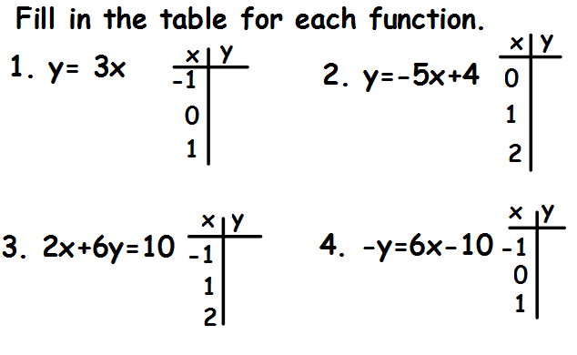
Find the range for the function when given the domain.
5. y = x – 7 6. y = 6x + 1
{-3, 0, 2, 5} {-4, -1, 3, 4}

7. y = 2x + 6 8. y = $\frac{1}{2}$x + 4
{ -2, 6, 10} {-6, -2, 4}

Teacher Twins©2014

Functions Practice Answer Key
Name _______________________________ Date _________
1666
10
4
1$\frac{1}{3}$
1
2
-6
-1
4
-3
0
3
Find the range for the function when given the domain.
5. y = x – 7 6. y = 6x + 1
{-3, 0, 2, 5} {-4, -1, 3, 4}
{-10, -7, -5, -2} {-23, -5, 19, 25}
7. y = 2x + 6 8. y = $\frac{1}{2}$x + 4
{ -2, 6, 10} {-6, -2, 4}
{2, 18, 26} {1, 3, 6}
Teacher Twins©2014

