**Writing Function Rules Practice**

**Name ____________________________________ Date __________**

**Write a function rule for each table.**

**.** 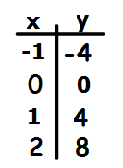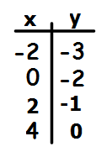

2.

1.

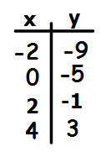 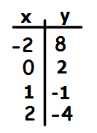

4.

3.

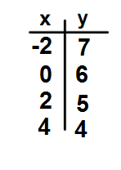

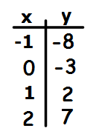

6.

5.

Teacher Twins©2014

**Writing Function Rules Practice Answer Key**

**Name ____________________________________ Date __________**

**Write a function rule for each table.**

**.** 

y = 1/2x - 2

y = 4x

2.

1.

 

y = -3x + 2

y = 2x – 5

4.

3.



y = -1/2x + 6

6.

y = 5x - 3

5.

Teacher Twins©2014