Solving Systems of Equations by Elimination Day 2 Practice
Name ______________________________________ Date ____________

Solve each system using elimination.

1. 2x + 3y = 7 2. x + y = 4
4x – y = 7 x – y = 12

3. 5x + 6y = 30 4. x + 2y = 6
10x + 12y = 60 2x + 2y = 8

5. -5x + y = -7 6. -7x – 2y = -13
3x + 2y = 12 x – 2y = 11

7. 3x + y = 5 8. 2x – 5y = 10
5x – 4y = -3 4x – 10y = 10

Teacher Twins©2014

Solving Systems of Equations by Elimination Day 2 Practice Answer Key
Name ______________________________________ Date ____________

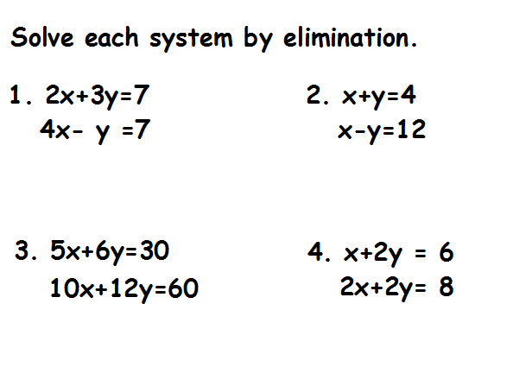

(8, -4)
(2,1)

(2, 2)
Infinite solutions

5. -5x + y = -7 6. -7x – 2y = -13
3x + 2y = 12 x – 2y = 11
(2,3) (3,-4)
7. 3x + y = 5 8. 2x – 5y = 10
5x – 4y = -3 4x – 10y = 10
Teacher Twins©2014
(1,2) no solution

