Combining Like Terms Practice
Name_______________________________ Date ________
Are the terms like? Write yes or no.
.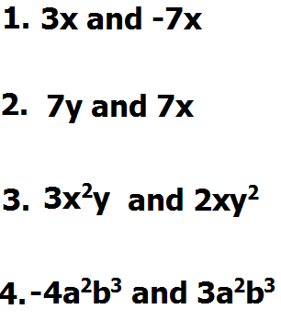
Simplify
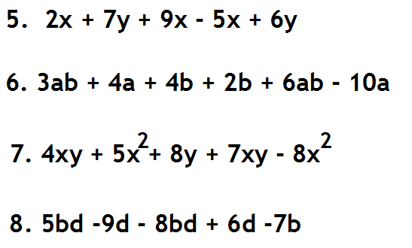
Teacher Twins©2014

