Finding the Volume of Cones Practice
Name______________________________________ Date_____________
Find the volume.
1. _____ 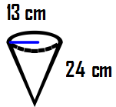 2 ______.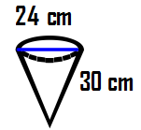

3. _____ 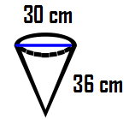 4._____ 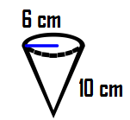
5. A paper cone has a height of 4 in and a radius of 2 in. How much water can the paper cone hold?

6. Find the volume of a cone with a diameter of 6 cm and a height of 10 cm.

7. Find the volume of a cone with a diameter of 15 cm and a height of 7 cm.

8. Find the volume of a cone with a radius of 22 cm and a height of 30 cm.

9. Find the volume of a cone with a radius of 24 cm and a height of 15 cm.

10. Find the volume of a cone with a diameter of 25 cm and a height of 17 cm.

