Finding the Volume of Spheres Practice
Name _______________________________________ Date____________
Find the volume of each sphere.
1. _____ 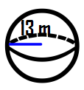 2._____ 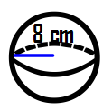
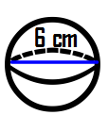3. _____ 4. _____ 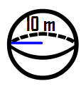

5. A basket ball has a diameter of 9 inches. What is the volume of the ball?
6. Find the volume of a sphere that has a radius of 15 cm.

7. Find the volume of a sphere that has a radius of 34 cm.

8. Find the volume of a sphere that has a diameter of 15 cm.

9. Find the volume of a sphere that has a radius of 22 cm.

10. Find the volume of a sphere that has a diameter of 22 cm.

