Scatter Plots and Line of Best Fit Practice
Name_______________________________ Date______________
Make a scatter plot for the data. Draw a line of best fit and write the equation for the line of best fit.
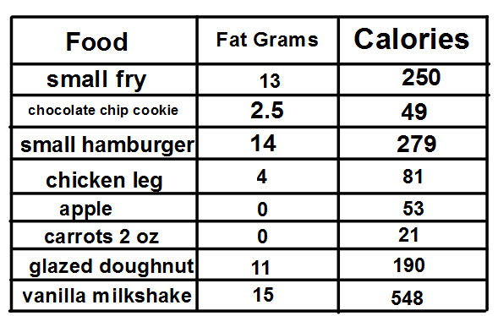

Teacher Twins©2014

