Reading Two Way Tables Practice
Name ___________________________ Date ____________
Use the table to answer the questions.
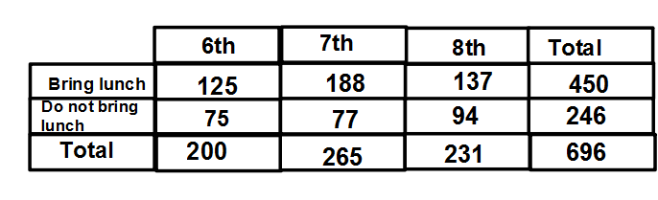
1. How many 6th grade students bring their lunch?
2. What percent of 7th graders do not bring their lunch?
3. What percent of students bring their lunch?
4. How many 8th graders bring their lunch?
5. How many students bring their lunch?
6. What percent of students do not bring their lunch?
7. What percent of 6th graders do not bring their lunch?
8. How many 7th graders bring their lunch?
9. What percent of 7th graders bring their lunch?
10. What percent of 8th graders do not bring their lunch?

Teacher Twins©2014

