Reading Two Way Tables Day 2 Practice
Name ____________________________________ Date _____________
Use the table to answer the questions.
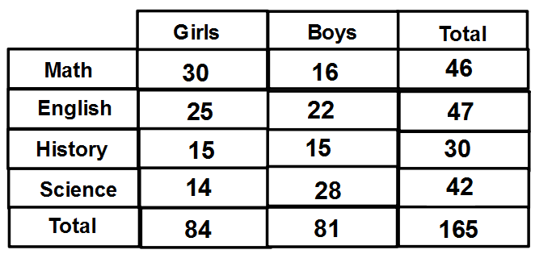
1. How many boys like Math best?
2. What percent of girls like English best?
3. What percent of students like History?
4. How many girls like Science best?
5. How many students like English?
6. What percent of students do not like Math best?
7. What percent of boys like Science best?
8. How many girls like History best?
9. What percent of boys do not like English best?

10. What percent of girls like Math best?

