Wanted Poster

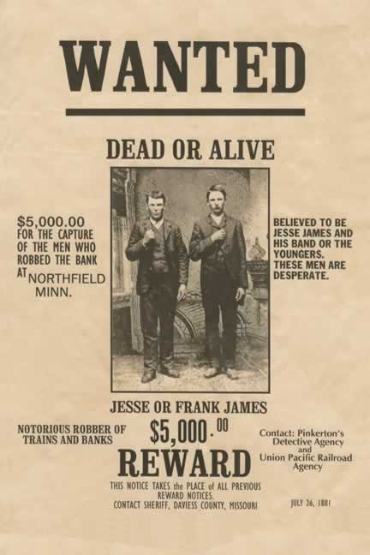

Your Task: Create a Wanted/Hero poster for either Hernan Cortes or Francisco Pizarro. If you consider the person to be a villain you will create a Wanted poster. If you think the person was good you will create a Hero poster.

Your poster must include:

1. A sketch of what the person probably looks like.
2. A reward amount listing the specific crime or heroic action the person did.
3. A made-up quote from a person living at the time showing what people might have said about this person.
4. The approximate date this poster would have been found.
5. A written description of what the person has done in his life.