**Writing Function Rules Practice**

**Name ____________________________________ Date __________**

**Write a function rule for each table.**

**.** 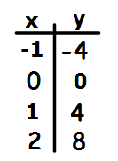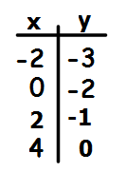

2.

1.

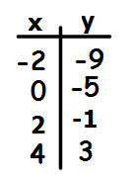 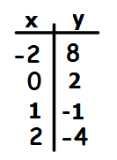

4.

3.

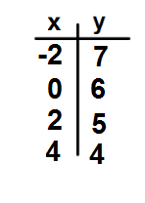

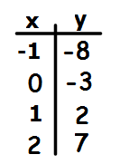

6.

5.