The Pythagorean Theorem Day 1 Practice
Name _______________________________________ Date _____________
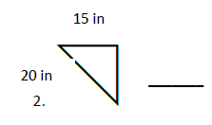
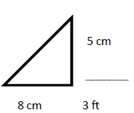
Find the missing side.
- 2.

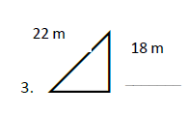
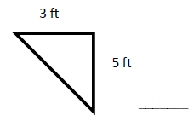
3. 4.

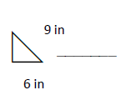
5.

6. a = 2 cm, b = 3 cm, c = ?
7. a = 15 ft, b = 18 ft, c = ?
8. a = ?, b = 22 ft, c = 26 ft
9. a = 5 cm, b = ?, c = 8 cm
10. a = 16 m, b = 20 m, c = ?

