Interpreting Graphs Practice
Name __________________________________ Date ______________
Write a story for each graph.
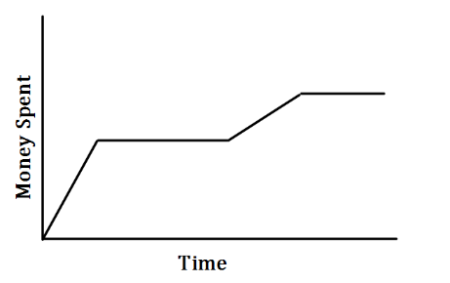
1.

____________________________________________________________________________________________________________________________________________________________
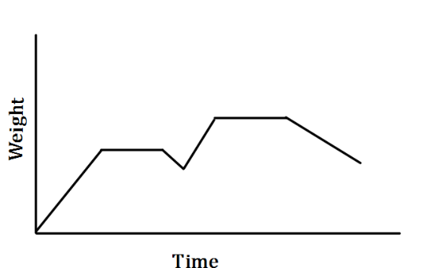
2.

_______________________________________________________________________________________________________________________________________________________________________________________________________________________________________________________________

Draw a graph for each situation.
3. Caleb increases his speed throughout the race.

4. Kay steadily increases his speed for the first part of his ride. He then keeps a constant speed as he rides.

Teacher Twins$©$2014

Interpreting Graphs Practice Answer Key
Name __________________________________ Date ______________
Write a story for each graph.
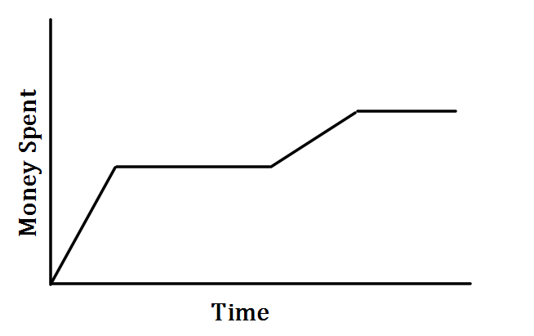
Any story where someone spends money. stops, spends, stops.
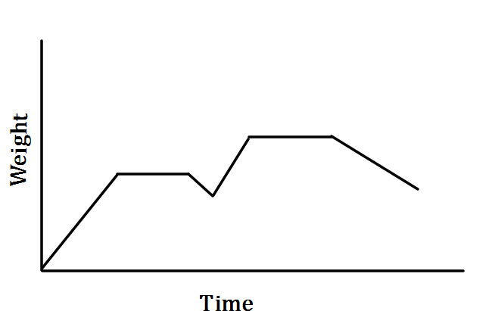
Any story where someone gains weight, stays the same, loses, gains. same, loses
3. 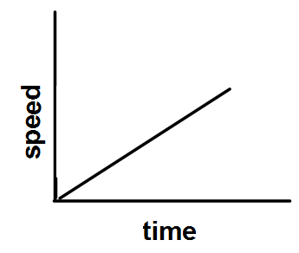 4. 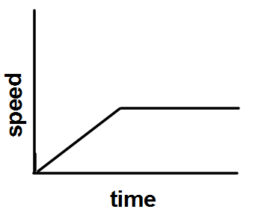

Teacher Twins©2014

Teacher Twins$©$2014

