Is it a Function? Practice
Name _______________________________________ Date _________
Is the relation a function?
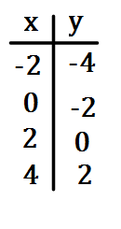
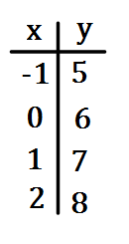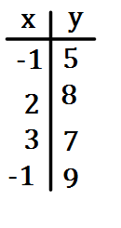
1.
2.
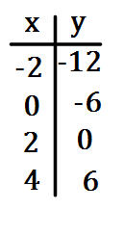
4.
3.
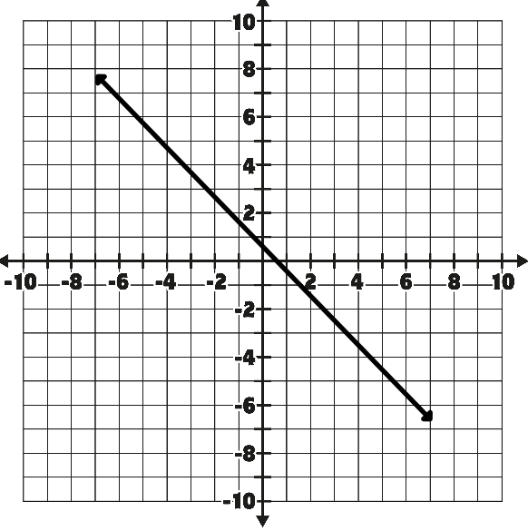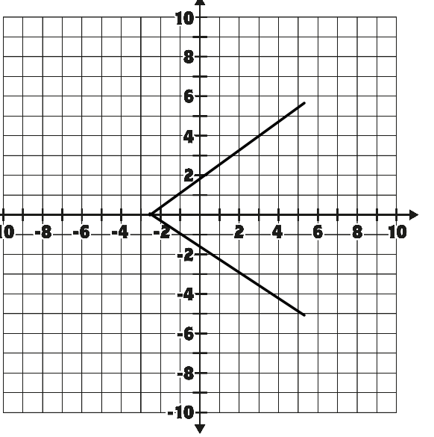
5.
6.

7. (-1, 1), (0, 2), (1, 3), (2, 4) 8. (3,6), (6, 3), (2,9), (3,7)

9. (2,4), (3, 5), (5, 7), (6, 4) 10. (-1,3), (1,4), (4,7), (1,0)
Teacher Twins©2014

