The Pythagorean Theorem Day 2 Practice
Name _________________________________________ Date _______________
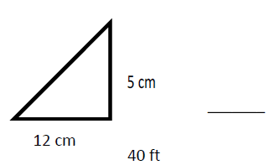
Find the missing side.
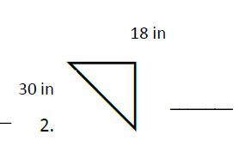
- 2.

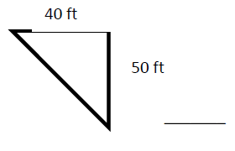
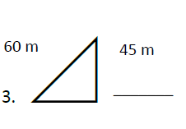
3. 4.

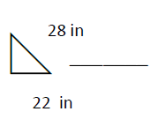
5.

6. a = 8 cm, b = 4 cm, c = ?
7. a = 6 m, b = 3 m, c = ?
8. a = 3.9 cm, b = ?, c = 11 cm
9. a =9.7 m, b = ?, c = 13.3 m
10. a = 5 cm, b = 2, cm. c = ?

