SS6G8 I can locate the Danube River, Rhine River, English Channel, Mediterranean Sea, European Plain, the Alps, Pyrenees, Ural Mountains, Iberian Peninsula, and Scandinavian Peninsula on a world and regional political- physical map.
I can locate the countries of Belgium, France, Germany, Italy, Poland, Russia, Spain, Ukraine, and United Kingdom on a world and regional political-physical map.
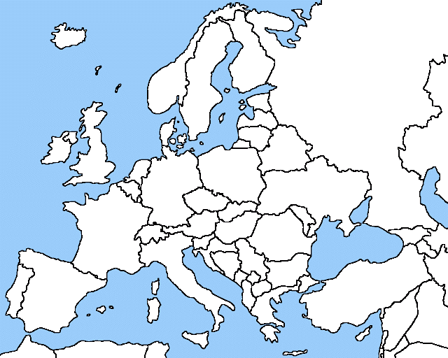

I. Political Features:
Label the following countries on the map:

- Spain
- France
- Italy
- United Kingdom
- Belgium
- Ukraine
- Russia
- Poland
- Germany
European Physical Features - MAP KEY

Rhine River

Danube River

Alps

Pyrenees Mountains

Ural Mountains

English Channel

Iberian Peninsula

Scandinavian Peninsula

Mediterranean Sea

European Plain

II. Physical Features:
Create a map key that includes symbols for the following physical features:

- Rhine River
- Danube River
- Alps
- Pyrenees Mountains
- Ural Mountains
- English Channel
- Iberian Peninsula
- Scandinavian Peninsula
- Mediterranean Sea
- European Plain
Draw the symbol for each feature next to the correct label on the map. Color all symbols!

