Reflections Practice

Name ___________________________ Date ________

Use the graph to answer the questions.

Triangle ABC is located at A(-4, 2), B(1, 3), C(-3, 6).

Triangle XYZ is located at X(-4, 1), Y(1, 7), Z(4, 4)

1. Reflect triangle XYZ across the x axis. Write the ordered pairs.
2. Reflect triangle XYZ across the y axis. Write the ordered pairs.
3. Reflect triangle ABC across the x axis. Write the ordered pairs.
4. Reflect triangle ABC across the y axis. Write the ordered pairs.

Rectangle ABCD is located at A(2, 6), B(2, -1), C(3, 6), D(3, -1)

Rectangle WXYZ is located at W(-3, 5), X(-3, -2), Y(3, 5), Z(3, -2)

1. Reflect rectangle ABCD across the y axis. Write the ordered pairs.
2. Reflect rectangle ABCD across the x axis. Write the ordered pairs.
3. Reflect rectangle WXYZ across the y axis. Write the ordered pairs.
4. Reflect rectangle WXYZ across the x axis. Write the ordered pairs.

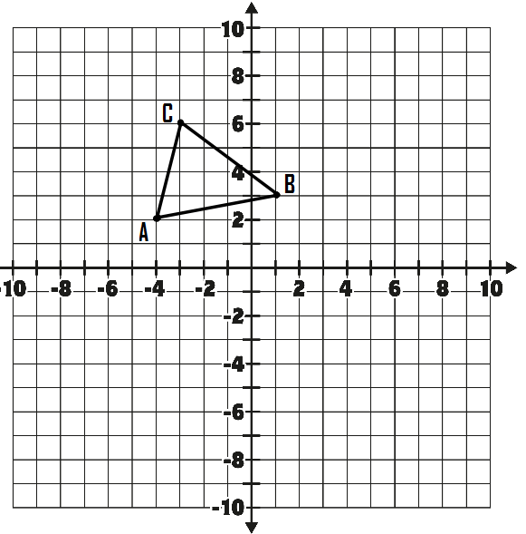

Teacher Twins©2014

Reflections Practice Answers

Name ___________________________ Date ________

Use the graph to answer the questions.

1. Reflect triangle XYZ across the x axis. Write the ordered pairs.

X’(-4,-1), Y’(1,-7), Z’ (4,-4)

2. Reflect triangle XYZ across the y axis. Write the ordered pairs.

X’(4,1), Y’(-1,7), Z’(-4,4)

3. Reflect triangle ABC across the x axis. Write the ordered pairs.

A’(-4,-2), B’(1,-3), C’(-3,-6)

4. Reflect triangle ABC across the y axis. Write the ordered pairs.

A’(4,2), B’(-1,3), C’ (3,6)

1. Reflect rectangle ABCD across the y axis. Write the ordered pairs.

A’(-2,6), B’(-2, -1),C’(-3, 6), D’(-3, -1)

1. Reflect rectangle ABCD across the x axis. Write the ordered pairs.

A’(2,-6), B’(2, 1),C’(3,- 6), D’(3, 1)

1. Reflect rectangle WXYZ across the y axis. Write the ordered pairs.

W’(3, 5), X’(3, -2), Y’(-3, 5), Z’(-3, -2)

1. Reflect rectangle WXYZ across the x axis. Write the ordered pairs.

W’(-3, -5), X’(-3, 2), Y’(3, -5), Z’(3, 2)

Teacher Twins©2014