Name:____________________ Date:_______________
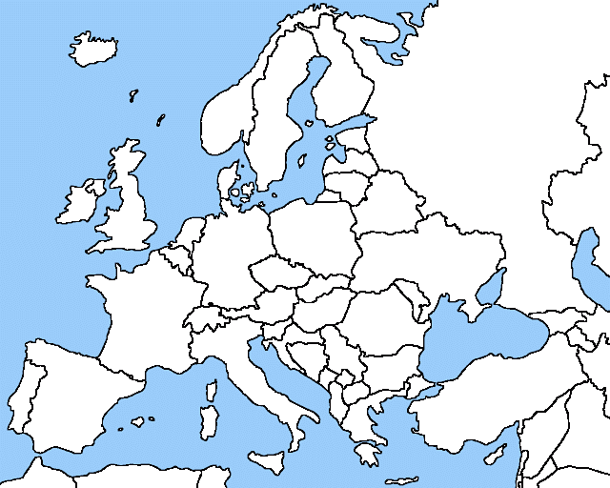
Political Features: Belgium, France, Germany, Italy, Poland, Russia, Spain, Ukraine, and United Kingdom / Physical Features: Danube River, Rhine River, English Channel, Mediterranean Sea, European Plain, the Alps, Pyrenees, Ural Mountains, Iberian Peninsula, and Scandinavian Peninsula

