Why should I recycle?
It is important to recycle. Here are some of the benefits of recycling.
You can save money, energy, and resources.
You can reduce the amount of waste sent to landfills.
You can help prevent water pollution
You can boost your creativity by thinking of ways to reuse old items.
You can prevent air pollution.
To prevent greenhouse gasses.
There are many important reasons for recycling!

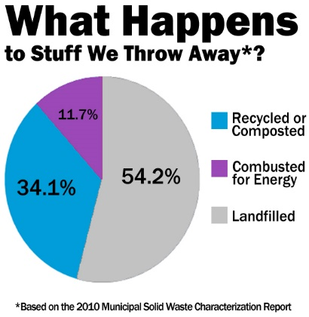
What should I recycle?
There are many things that you can recycle. Here are some things you can recycle.
- Aluminum.
Aluminum cans are 100 percent recyclable and can be reused over and over again!
- Glass.
Recycling 1 glass bottle can light a 100 watt bulb for many hours!
- Paper.
Paper makes up about one-third of the waste stream in the United States! That is a lot of paper! That is a great reason to recycle paper.
- Steel cans.
Steel could be remade into car parts and materials. Steel can be reused over and over again.
- Plastic.
One ton of recycled plastic saves 5,774 kilo watts of energy.

Fun facts!
Americans use 2,500,000 plastic bottles every hour!

In 2008, Americans recycled 7 million tons of metals, eliminating the equivalent of nearly 25 million metric tons of carbon dioxide!

Americans currently discard about 2.7 million tons of aluminum each year. Of that, about 50 percent is recycled.

The average person has the opportunity to recycle more than 25,000 cans in a life time.

Every 3 months, Americans throw enough aluminum in the landfills to build our nations entire commercial air fleet

What happens when we don’t recycle?
When we don’t recycle, our trash goes to a place called a landfill. Spaces to put landfills are running out and people are trying to reduce the amount of trash. It could be dumped into the ocean, and it could pollute the waters. The landfills would keep getting bigger and bigger to where it would be very toxic.
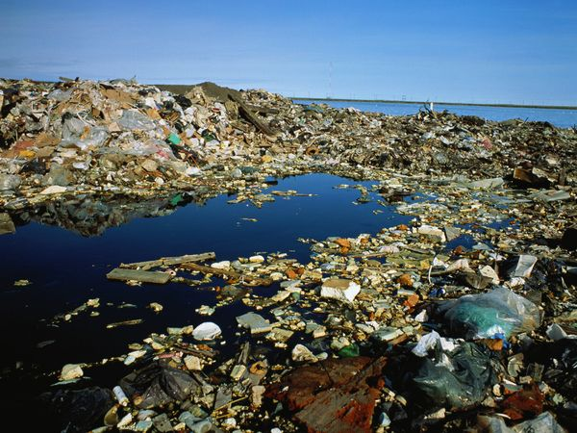

What I have just described is only what COULD be. If we all work together to recycle, none of this would ever happen!

Effects of recycling
The effects of recycling can be various. The first effect is on animal life. Did you know that many animals are killed of severely hurt by unrecycled trash in their environment? When you recycle anything, you just might be saving a poor animal’s life, as well as saving money, energy and time.
The next effect is boosting creativity! When I recycle, before I put it in the bin, I always think, what could I make out of this? Doing this makes me and many others have a creative mind! There are also many other benefits! If you have any other benefits to list, tell Mrs. Taltons 6th period science class!

Sources: https://www.epa.gov/recycle/recycling-basics
http://www.wm.com/thinkgreen/what-can-i-recycle.jsp
http://climatekids.nasa.gov/recycle-this/
https://www.ecocycle.org/files/pdfs/why_recycle_%20brochure.pdf
http://www.recycling-guide.org.uk/importance.html
http://www.conserve-energy-future.com/Why_Should_We_Recycle.php
http://ngm.nationalgeographic.com/2008/01/high-tech-trash/recycling-text
http://www.earthsfriends.com/why-recycling-important/
http://www.lessismore.org/materials/28-why-recycle
http://www.care2.com/causes/top-10-most-important-items-to-recycle.html
http://www.kidzworld.com/article/26804-top-10-ways-to-recycle

