Name: _______________________

Australia’s Geography & History
Study Guide

GEOGRAPHY:
1. What is the climate like in central Australia?

2. Why is southeastern Australia a popular place to live?

3. Why do very few people live in the Great Victoria Desert?

4. Where is the Great Barrier Reef located?

5. Describe the landscape of Australia:

6. Why are many of Australia’s animals found nowhere else on Earth?

7. Label the following features on the map below:
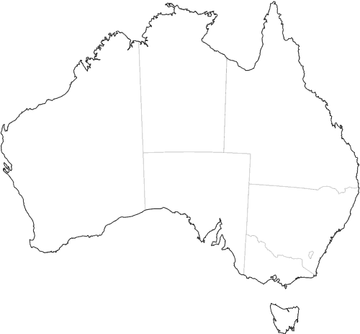
- Great Barrier Reef, Coral Sea, Canberra, Great Victoria Desert, Indian Ocean, Ayers Rock

HISTORY:
8. Where did the Aborigines come from?

9. Describe Aboriginal culture:

10. What do the Aborigines and the Aztec/Inca have in common?

11. Which weapon did the Aborigines invent?

12. Which country’s culture had the greatest impact on the language & religion of Australia?

13. What advantages did the British have over the Aborigines?

14. Why did the British want to start a colony in Australia?

15. Who were the first settlers in Australia? When did they colonize the country?

16. What did the British do to the Aborigines?

