ANSWER KEY

Australia’s Geography & History
Study Guide

GEOGRAPHY:
1. What is the climate like in central Australia?
Hot and humid
2. Why is southeastern Australia a popular place to live?
Climate is temperate and receives more rainfall
3. Why do very few people live in the Great Victoria Desert?
Hot climate, little rainfall
4. Where is the Great Barrier Reef located?
In the Coral Sea, off the northeast coast of Australia
5. Describe the landscape of Australia:
large, dry central region with mild climates along the southeastern coastal areas
6. Why are many of Australia’s animals found nowhere else on Earth?
because of the country’s great distance to and from other large landmasses
7. Label the following features on the map below:
- Great Barrier Reef, Coral Sea, Canberra, Great Victoria Desert, Indian Ocean, Ayers Rock
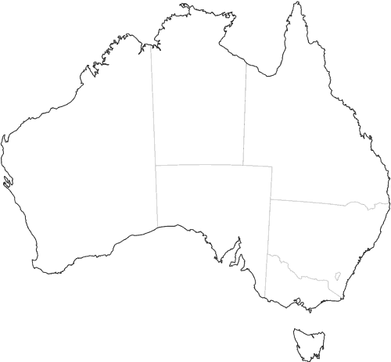

Coral Sea

Great Barrier Reef

Indian Ocean

Ayers Rock

Great Victoria Desert

Canberra

HISTORY:
8. Where did the Aborigines come from?
Asia
9. Describe Aboriginal culture:
Belief in Dreamtime; spirits in nature
10. What do the Aborigines and the Aztec/Inca have in common?
Europeans wiped out many because of diseases and weapons
11. Which weapon did the Aborigines invent?
boomerang
12. Which country’s culture had the greatest impact on the language & religion of Australia?
United Kingdom
13. What advantages did the British have over the Aborigines?
weapons
14. Why did the British want to start a colony in Australia?
Jails were becoming overcrowded & they needed a place to send prisoners
15. Who were the first settlers in Australia? When did they colonize the country?
British – place to send prisoners (penal colony)
16. What did the British do to the Aborigines?
Many were killed because of lack of immunity to European diseases; British also took their homeland and forced them to relocate

