Name _________________________________________ Date _________________


Ratios and Proportions/Rates/6.RP2 – Lesson 7

(ex 1) Write Tillman’s record time as a ratio in fraction form.
*Remember to simplify!

This example is special because we have 2 different units being compared, meters and seconds.

A rate is a _______________________________!
(ex) Tillman’s skateboarding rate

A rate is often found in the following real-world situations:
- Distance and Time (ex) Homer ran 60 yards in 20 seconds.

- Measurement (ex) A brownie recipe has 4 cups of flour for every 2 cups of sugar.

- Prices (ex) Casey $80 on 8 pizzas.

A unit rate is a _____________________________________________.

(ex 1) Homer ran 60 yards in 20 seconds.
Step 1: Write as a rate in fraction form.

Step 2: Simplify the rate so the denominator is 1.

This unit rate means that, Homer ran ____ yards per second.

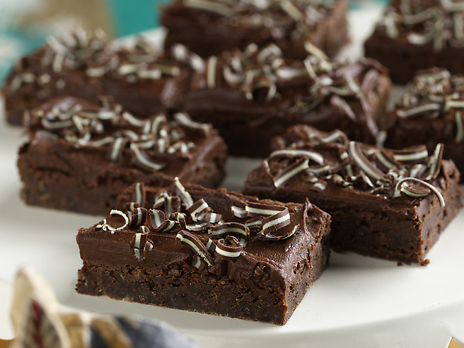
Try with your partner!
(ex 2) A brownie recipe has 4 cups of flour for every 2 cups of sugar.
Step 1: Write as a rate in fraction form.

Step 2: Simplify the rate so the denominator is 1.

This unit rate means that, there are _____ cups of flour for every cup of sugar.

Challenge – Partner Work
(ex 3) Ricardo wants to buy 40 key chains for his new business. An online merchant has the following special posted.
SPECIAL:
40 Key Chains for $80

Is Ricardo right? Why or why not?

Summary:
- A rate is a ratio that compares 2 different _________.

- A unit rate is a ratio in fraction form that has a _________________ of 1.

- How are rates and unit rates similar?

- How are rates and unit rates different?

- One real world example of when we use rates and unit rates is _________________________ .

Name:
Classwork 6RP2 Class work Lesson 7

Fill in the numbers for each real world situation to write a rate.

- Alexis read 100 pages in 97 minutes. _______pages
minutes

2) Marvin texts 25 words in 2 minutes. _______words
minutes

3) Miguel worked 240 hours in 13 weeks. _______hours
weeks

4) There are 120 students on 7 buses. _______students
buses

Fill in the numbers for each real world situation to write a rate and then simplify to write as a unit rate.

5) Sara types 100 words in 10 minutes.

6) Mei spends $15 on 3 t-shirts.

7) Based on the information in question #6, how much did Mei spend per t-shirt? Explain with a sentence, how you got your answer!

8) Four friends are trying to decide how to equally divide 8 hamburgers.






- Write a ratio in 3 ways to represent the comparison between hamburgers and people. Make sure to simplify your answer!

- Is this comparison a rate? Why or why not?

- How many hamburgers will each person get if they are divided equally?


9 ) Mrs. Johnson buys her class 10 clipboards for her students at the beginning of the year. The clipboards cost $30 altogether. Answer the questions below based on this information.

- Write a rate that compares clipboards to dollars ($) as a fraction.

- Write this ratio as a unit rate.

- Fill in the blanks: Mrs. Johnson spent $____ on each clipboards for her students.

