Teacher Twins©2014

Triangles Practice

Name______________________________________ Date_____________

Find the missing angle of the triangle.

1. **If<1 = 27⁰ , < 2 = 115⁰, what is the measure of < 3?**

**2. If<1 = 20⁰ , < 2 = 135⁰, what is the measure of < 3?**

**3. If<1 = 55⁰ , < 2 = 47⁰, what is the measure of < 3?**

**4. If<1 = 27⁰ , < 2 = 125⁰, what is the measure of < 3?**

**5. If<1 = 27⁰ , < 2 = 86°, what is the measure of < 3?**

**6. If<1 = 36⁰ , < 2 = 33⁰, what is the measure of < 3?**

**7. If<1 = 59° , < 2 = 110°, what is the measure of < 3?**

**8. Find x.** 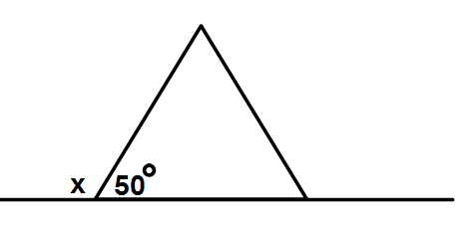

Teacher Twins©2014

Triangles Practice

Name______________________________________ Date_____________

Find the missing angle of the triangle.

1. **If<1 = 27⁰ , < 2 = 115⁰, what is the measure of < 3?**

**38⁰**

**2. If<1 = 20⁰ , < 2 = 135⁰, what is the measure of < 3?**

**25⁰**

**3. If<1 = 55⁰ , < 2 = 47⁰, what is the measure of < 3?**

**78⁰**

**4. If<1 = 27⁰ , < 2 = 125⁰, what is the measure of < 3?**

**28⁰**

**5. If<1 = 27⁰ , < 2 = 86⁰, what is the measure of < 3?**

**67⁰**

**6. If<1 = 36⁰ , < 2 = 33⁰, what is the measure of < 3?**

**111⁰**

**7. If<1 = 59⁰ , < 2 = 110⁰, what is the measure of < 3?**

**11⁰**

**8. 130⁰**