Writing Linear Equations When Given a Point and the Slope Day 2 Practice
Name ________________________________________________________________ Date ___________
Write an equation in slope intercept form when given the slope and a point.

- m = 3, (5, -2) 2. m = -5, (5, 4)

- m = 0, (-3, 1) 4. m = -2, (0, 6)

5. m = $\frac{2}{3}$ , (-1,0) 6. m = $\frac{3}{4}$ , (-2, -4)

7. m = 6, (2, -5) 8. m = -4, (-7, 8)

9. m = 1, (-5, -2) 10. m = undefined, (6,3)

Teacher Twins©2014
Writing Linear Equations When Given a Point and the Slope Day 2 Practice Answer Key

Write an equation in slope intercept form when given the slope and a point.

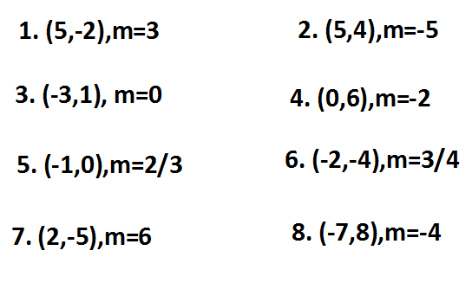
y = -4x - 20
y = 6x - 17
y = 3/4x -2.5
y = 2/3x + 2/3
y = -2x + 6
y = 1
y =-5x + 29
y = 3x - 17
9. m = 1, (-5, -2) 10. m = undefined, (-3,1)
y = x + 3 x = -3

Teacher Twins©2014

